Marko Smiljanic

CSc 165 Assignment 2

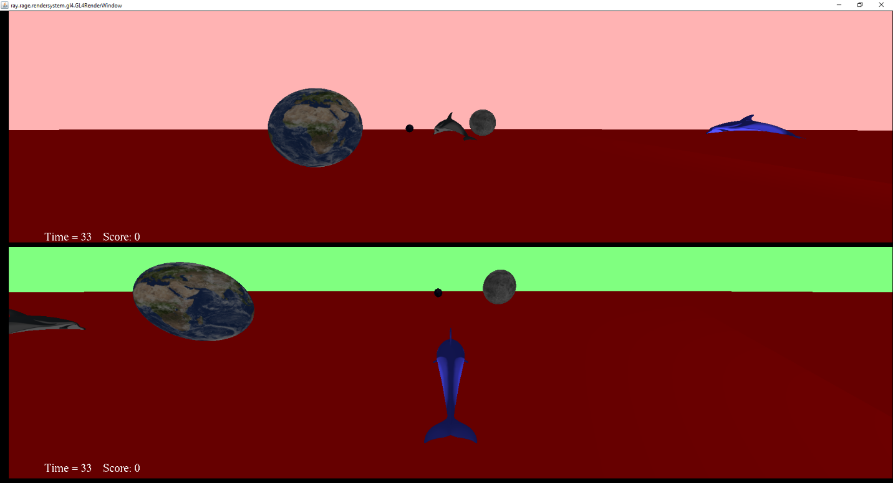

**How to Compile and Run:**

Included in the assignment folder are two batch files, compile and run. Double click compile.bat to compile and generate all the necessary class files. After compiling has finished, double click run.bat to run the game. The same compiling can be done by opening a powershell window in the Assignment 2 folder. From there, first type “javac a2\*.java” and hit enter. Once the compiling is done, type in “java -Dsun.java2d.d3d=false a2.MyGame” and hit enter. These two options will run the game.

**How the Game is Played:**

The objective of this game is to be the first dolphin to score all three planets. Player 1 is on the top viewport and has control over the keyboard. Player 2 is on the bottom viewport and has control of the gamepad. If a player scores a planet, it will move up and down or expand and shrink, respective of dolphin 1 or dolphin 2. If a player captures all 3 planets, then they will spin around the map to signify the game is over. A player can go and recapture another players planets so it is a game of chase to move back and forth and capture all planets.

**Inputs:**

**(Keyboard Controls)**

W – Move Forward, A – Move Left, S – Move Back, D – Move Right, Q – Yaw Left,

E – Yaw Right, Up – Rotate Camera Up, Down – Rotate Camera Down,

Left – Rotate Camera Left, Right – Rotate Camera Right, T – Zoom In, G – Zoom out

**(Controller Controls)**

X-axis - Move Left and Right, Y-axis – Move Up and Down,

RX-axis – Rotate Camera Left and Right, RY-axis – Rotate Camera Up and Down

Button 2 – Zoom out, Button 4 – Zoom in, Button 5 – Yaw Left, Button 6 – Yaw Right

**Node Controllers:**

I created two node controllers, the first is a scaleController that makes the planet scale out and in when the 2nd player has scored the planet. The second is a liftController that makes the planet move up and down when the 1st player has scored the planet.

**Group/Child Node Relationship:**

My Group node controls all the planets in the game and once a player has scored all three planets, a rotationController will be applied to this group that will make all planets rotate around the scene, signifying that there is a winner.

**Camera Controller:**

My camera controller is called Camera3Pcontroller and it is an orbit controller that manages all the camera and movement functions

**Unfinished Requirements:**

I do not believe that I have missed any game requirements.

**Special Additions:**

I have added the ability to yaw on the keyboard and controller by using the Q/E keys and the 5/6 buttons.

**Assets:**

**(Objects)**

DolphinHighPoly.obj, Earth.obj – Provided with School Materials

**(Textures)**

Dolphin_HighPolyUV.jpeg, moon.jpeg, earth-day.jpeg, earth-night.jpeg – Provided with school materials

bright-red.jpeg – Provided by professor